**Errors Counter User Guide**

1. Extract/Unzip the files to any location you prefer (Script might not work if the files aren’t extracted or unzipped)
2. After extracting, you should see the following files in the folder (Sample files are provided. They may be deleted if no longer needed.):   
   Text, table

   Description automatically generated with medium confidence
3. To use the script, the PDF you want to work on should always be within the same folder as the script.
4. Open the “_list.txt” file to modify the list of errors you want to find in the report.
5. Copy the file name of the PDF you’re working on. (Do not include .pdf extension).
6. Run the script “errors-counter”.
7. If you see the prompt below, just click “More info”, then “Run anyway”.  
   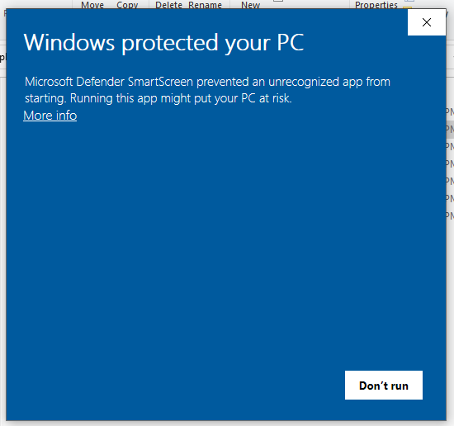
8. Wait for the terminal to open and prompt for the file name (it might take a while to load):  
   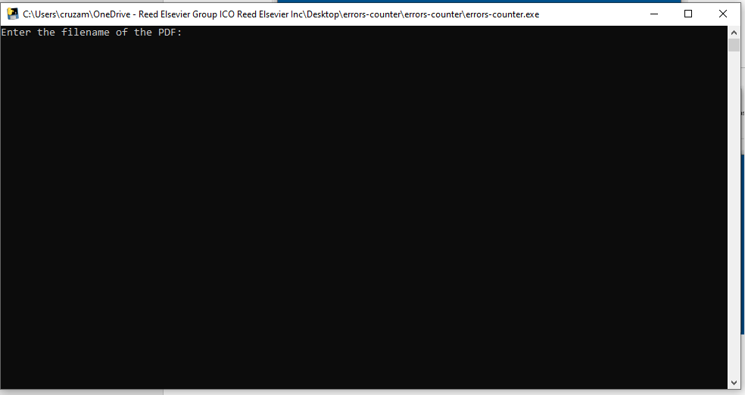
9. Paste the copied file name and press the **Enter** key.
10. Please wait for it to process and don’t close the terminal. You may leave it in the background and will auto-close once complete. It may take a while especially for PDFs with a thousand or more pages.
11. The output would be an Excel file ending in “_report”

For any issues with this script, please contact me: Aldrin Renz Cruz (aldrinrenzcruz@proton.me).